**KINR Annual Workshop (****Video Conference****).**

**Kyiv. 20 -21 January 2025**

**“High Energy Physics.**

**Theoretical and Experimental CHALLEGES”**

**“HEP-TEC-2025”**

**Abstract template:**

**INVESTIGATION OF THE INFLUENCE OF LOGARITHMIC CORRECTIONS AGAINST   
THE BACKGROUND OF TWO-PHOTON EFFECTS IN ELASTIC   
ELECTRON-DEUTERON SCATTERING**

**Ya. D. Krivenko-Emetov**

*National Technical University of Ukraine “Igor Sikorsky Kyiv Polytechnic Institute”, Kyiv, Ukraine*

To date, a vast amount of experimental data on the interaction of polarized and unpolarized deuterons with large momentum transfer has been accumulated. This opens up new opportunities for studying the structure of the deuteron at distances smaller than the nucleon size. In the asymptotic region, where the absolute value of the momentum transfer squared significantly exceeds the deuteron’s mass squared (), predictions of the deuteron’s form factor can be obtained based on phenomena of asymptotic freedom and the factorization theorem. These predictions can be roughly divided into two parts: (i) predictions based on “quark counting rules”, which are relatively well supported by experimental comparisons, and (ii) more subtle logarithmic corrections [1]. However, there are no stable experimental data to assess the contribution of the latter. Therefore, they have not received as wide recognition [2]. On the other hand, within the framework of Quantum Electrodynamics (QED) the role of higher-order perturbation theory going beyond the single-photon approximation in electron scattering on hadronic systems has been widely discussed [3].

In the perturbative Quantum Chromodynamics (pQCD) approach, the masses of quarks and hadrons are neglected at high energies. The amplitude of the investigated process is expressed through the amplitude of hard electron-quark scattering, multiplied by the nonperturbative part, which is associated with the distribution functions of quarks and gluons in the deuteron in the initial and final states. When calculating the amplitude of hard (particularly perturbative) scattering, the deuteron is considered as a system of 6 quarks moving collinearly, each of which contributes to the deuteron’s momentum fraction , where ,, . It is assumed that the main deuteron form factor in the perturbative region can be represented as the product of three factors, exhibiting dipole, power-law, and logarithmic behavior, respectively(and is non-perturbative parameters)[1]:

,

 is the running strong coupling constant, and  and  is the socalled ”anomalous dimensions” of deuteron and nucleon, which depends on the number of flavors and colors and $Λ_{QCD}^{2}$ is the characteristic scale factor of pQCD.

In the two-photon appr/oach, two types of two-photon exchange are calculated: one associated with Feynman diagrams in which two photons interact with the same nucleon , and the other with diagrams  in which each of the two virtual photons interacts with different nucleons [2]. These effects are conditionally logarithmic in nature [3]. Accounting for higher orders of perturbation theory in pQCD and QED separately has not led to a significant improvement in describing experimental data [1], [4]. It would be interesting to compare the theoretical description of experimental data on elastic electron-deuteron scattering with and without consideration of two-photon corrections. Based on the theoretical and experimental analysis conducted previously [3], [4]beyond the single-photon order of perturbation theory ( and  are the target and magnetic structure functions in the one-photon approximation), we propose the following phenomenological parameterization of two-photon corrections (written in terms of the [fine structure constant](https://en.wikipedia.org/wiki/Fine-structure_constant#In_non-SI_units) in natural units, , ):

,

,

where ,  and , , are fitting parameters of the model.

The asymptotic logarithmic behavior predicted by the pQCD has been found to improve slightly with two-photon corrections (b) compared to without them (a) (respectively, solid and dotted lines in Fig. 1 ).

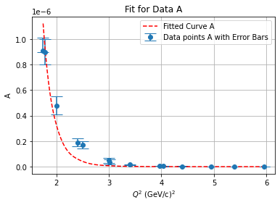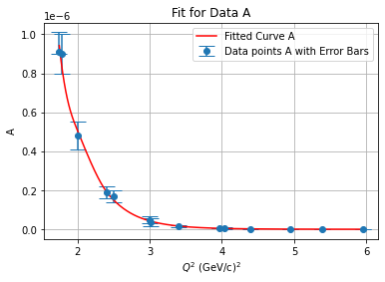

a b

Fig. 1. Optimal fits for the deuteron structure function . The uncertainties on the data points are statistical and systematic uncertainties combined in quadrature.

1. A.P. Kobushkin, Ya.D. Krivenko-Emetov Scientific works of the Institute of Nuclear Research 49–69 (2003) 3.
2. Jingyi Zhou et al. Eur. Phys. J. A 59 (2023) 256.
3. A.P. Kobushkin A., Ya.D. Krivenko-Emetov, and S. Dubnicka Phys. Rev. C **81** (2010) 054001.
4. A.P. Kobushkin A., Ya.D. Krivenko-Emetov, and S. Dubnicka Phys. Rev. C **84**(2011) 054007.