**TIMEPIX3: MULTI-CHANNEL HYBRID PIXEL DETECTOR**

**D. M. Ramazanov1, O. S. Koavalchuk1, А. V. Chaus1, V. M. Pugatch1**

*1 Institute for Nuclear Research, National Academy of Sciences of Ukraine, Kyiv, Ukraine*

Timepix3 [1] is a universal integrated circuit suitable for reading out semiconductor and gas-filled detectors. Timepix3 can be used in a wide range of applications, from X-ray imaging to particle trajectory reconstruction. Depending on the application requirements, the user can choose one of three data acquisition modes available in Timepix3 [2]. In data transfer mode, information about the arrival time and charge magnitude simultaneously with the coordinates of the active pixel is sent outside the chip for each recorded signal. The chosen architecture allows continuous data readout at a rate of up to 4*107 hits/s/cm2 [3].

For visualization and calibration, there is the possibility of working in frame data readout mode (without continuous data transfer).

Features

- Pixel size 55 µm x 55 µm

- 256 x 256 pixels

- Timepix3 is suitable for reading both semiconductor and gas-filled detectors

- Single threshold values ​​per pixel each with 4 bits of local tuning

- Two main measurement modes: (1) simultaneous 10 bit ToT (time over threshold mode) and 18 bit TOA (time of arrival mode) and (2) 10 bit

event counting and 14 bit integral TOT

- TOT for large positive charges

- Fast TOA with 1.56 ns accuracy

- Data-driven readout: no dead time, for a maximum hit rate of 4*107 hits/s/cm2

- Shutdown/wake-up functions for tests

- 3-sided contact (with one dead edge of 1.2 mm)

- TSV

Applications: X-ray distribution visualization, particle track reconstruction, electron microscopy.

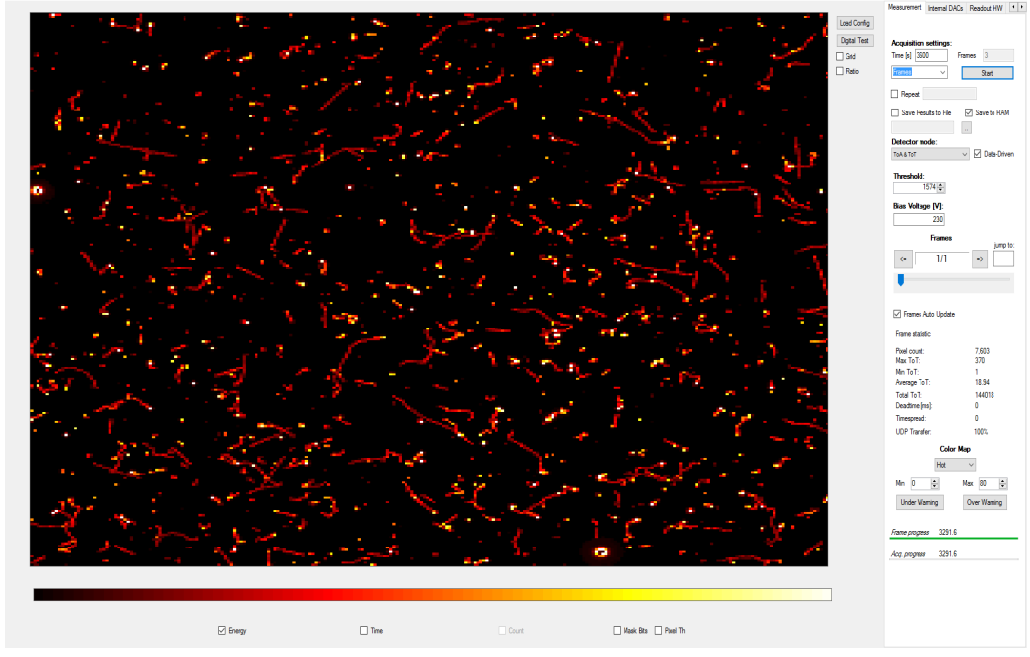

Frame with the Timepix3 response to mixed radiation (gamma, electrons, alpha) from the U-238 calibration source.

Initial measurements performed with a calibration source demonstrate the functionality of the chip and achievement of the stated specifications with pixel positioning accuracy, time resolution and noise characteristics. Power consumption is below 1 W/cm2, and the bandwidth reaches 20 Mrad/s/cm2 at 40 MHz. All output channels operate at a maximum speed of 640 Mbit/s. Timepix 3 will be used for quality control of RMS4 during 2MeV electron beam irradiation tests.

This project has received funding through the EURIZON project, which is funded by the European Union under grant agreement No.871072. Grant №3014.

1. A.G. Magner et al. arxiv:2308.07784. Submitted to Eur. J. Phys. A 2023.
2. P. Möller et al. Atomic Data and Nuclear Data Tables 109-110 (2016) 1.
3. B. Le Crom et al. Phys. Lett. B 829 (2022) 1