RESEARCH OF THE BEHAVIOR OF THE EFFECTIVE POTENTIAL IN SYSTEMS WITH PHASE TRANSITIONS THROUGH THE PRISM OF A–D–E TYPE SINGULARITIES

T. V. Obikhod

Institute for Nuclear Research, National Academy of Sciences of Ukraine, Kyiv, Ukraine

The discovery of the Higgs boson introduced a host of new questions instead of bringing closure, as its existence seems closely related to one of the Standard Model's most perplexing mysteries: the reason for the presence of three generations of matter, each exhibiting dramatically varying masses. Concealed within its interactions might be new physics, which could potentially be revealed by a future electron-positron collider through the examination of collisions at precisely selected energy levels. The Standard Model is viewed not as an ultimate explanation, but as a robust and effective foundation to examine nature across all scales, from the subtle aspects of particle decay to the characteristics of the Higgs and the high-energy structures formed during collisions [1].
An extended scalar sector of the Higgs boson holds a striking possibility: a sharp, strongly first-order electroweak phase transition (FOPT). Within the Standard Model alone, a Higgs mass of 125 GeV leads only to a smooth crossover—a gradual shift without dramatic discontinuity. But introduce new, light scalar degrees of freedom, and the Higgs potential can reshape dramatically. In models such as the two-Higgs-doublet (2HDM) framework, adjustments to the Higgs self-coupling can replace the mild crossover with a decisive first-order transition that remains consistent with existing data.
Modern theory of critical phenomena in condensed matter and particle physics extensively uses Arnold’s classification of simple (elementary) singularities of smooth functions of many variables (the A–D–E series) [2]. This classification uniquely relates the topology of the effective potential near a critical point to universal critical exponents, scaling laws, and the universality class of the system. The best-known physical realizations are:
- $A₂$(cusp) — tricritical point,
- $E₆$— triple merging of phase diagrams,
- $E₈$— the hypothetical most degenerate singularity of cubic symmetry $SU(3)×SU(2)×U(1)$.
One of the key tools in algebraic geometry for determining the type of singularity is the Milnor number $μ$ — the dimension of the local algebra $ℂ[[x₁,…,xₙ]]/⟨∂V/∂xᵢ⟩$. For all simple A–D–E catastrophes, the value of μ is strictly fixed and always less than 9 (the largest is $μ(E₈) = 8$). Therefore, if in a real physical model μ ≥ 9, the corresponding critical point is guaranteed not to be elementary and belongs to the much broader class of “composite” or “non-simple” singularities.
We investigate the most common and phenomenologically well-motivated extension of the Standard Model — a real scalar $Z₂$-symmetric singlet s interacting with the Higgs doublet via the Higgs portal. The effective potential for two real scalar fields (the neutral component of the Higgs h and the singlet s) has the form
$V(h,s) = −(μₕ²/2) h² + (λ/4) h⁴ − (μs²/2) s² + (b₄/4) s⁴ + (a₂/4) h² s².$
Under a strict $Z₂$ symmetry (s → −s), only even powers of s remain, reducing the potential to the classical Higgs-portal with parameters $a₂ = 8, m_{S} ≈ 4, m_{t} ≈ 692 GeV, sinθ = 0$ shown in Fig. 1.
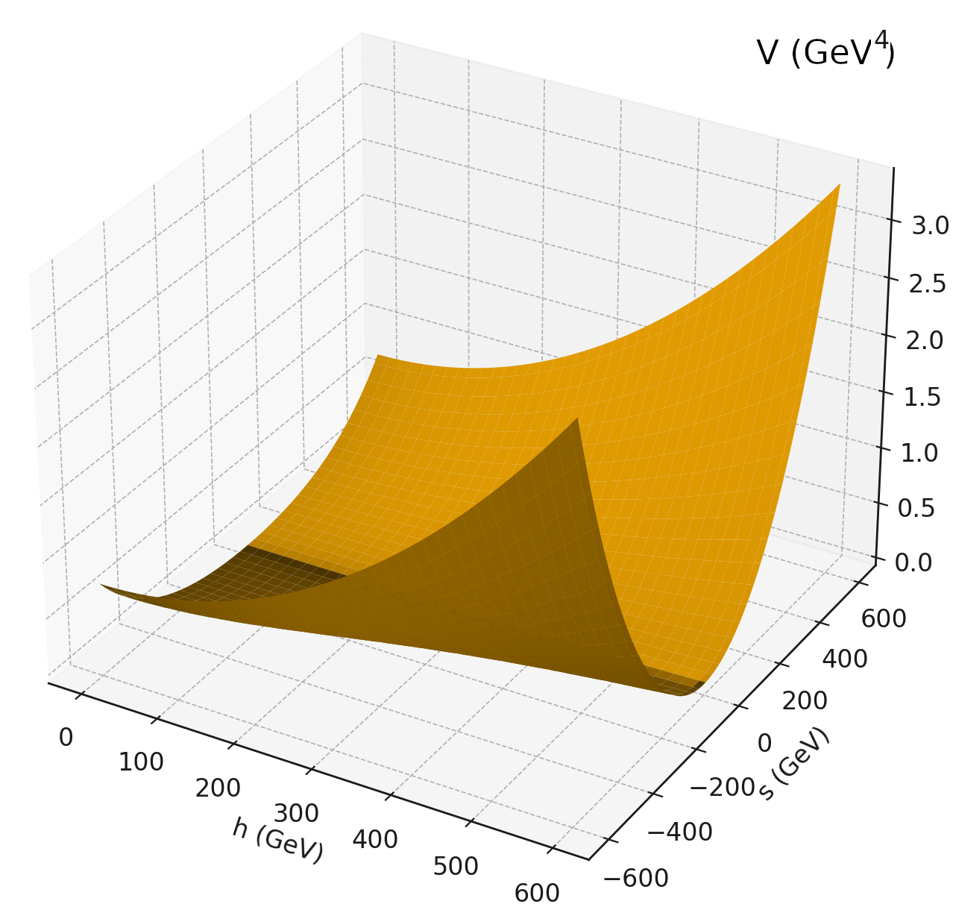

Fig. 1. 3D surface of the potential with a Z₂-symmetric singlet.

After shifting the fields to the electroweak vacuum $h = v + x, s = y (v ≈ 246 GeV)$ and expanding up to fourth order inclusive, we obtain the effective potential in the vicinity of (x,y) = (0,0). The critical point (0,0) is a minimum (or a saddle point in the case of strong mixing), and we analyze the ideal of partial derivatives $J = ⟨∂V/∂x, ∂V/∂y⟩$in the ring $ℂ\{x,y\}$.
Using computation of the Groebner basis of the ideal J and counting the standard monomials, it was found that throughout the entire physically allowed parameter space [3]:
$m_{S} = 400 GeV – TeV, |sin θ| ≤ 0.3, a₂ = 1–8, b₄ > 0, arbitrary Z₂-breaking b₁, b₃, a₁$
within LHC-compatible bounds, the Milnor number is stably μ = 9.
The value μ = 9 remains robust even in extreme limiting cases:
- at maximal mixing sin θ ≈ 0.3, when the electroweak vacuum ceases to be the global minimum and is strongly displaced;
- when large $Z₂$-breaking linear and cubic terms are introduced (b₁ up to 10⁵ GeV, b₃ up to ±10⁴ GeV);
- for arbitrarily large singlet mass and portal coupling.
None of these extreme regimes reduces μ below 9 or moves the singularity into the simple A–D–E class. Consequently, the electroweak vacuum in the simplest and most studied scalar extension of the Standard Model fundamentally cannot be described by any elementary Arnold catastrophe.
The result has several important implications:
a) Searching for exceptional E₆–E₈ singularities in the scalar sector beyond the Standard Model requires significantly more complicated models (additional singlets, triplets, higher representations, or explicit breaking of global symmetries);
b) The stability of $μ$ = 9 explains the remarkable flatness of the potential along the singlet direction (the well-known “flat direction” in the Higgs portal), with cosmological consequences (inflation, strong first-order phase transitions, etc.);
c) The algebraic technique (Groebner bases + Milnor number) proves to be a powerful and universal tool for classifying critical points in multi-parameter field theories.
Thus, in real scalar extensions of the Standard Model with a single Z₂ singlet, the electroweak vacuum is always characterized by a composite singularity with Milnor number 9, which excludes it from belonging to the exotic simple A–D–E catastrophes, in particular to the theoretically most degenerate E₈.

- Jorge de Blas et al. Physics Briefing Book: Input for the 2026 update of the European Strategy for Particle Physics. arXiv:2511.03883 [hep-ex].
- Mikhail Entov. On the A-D-E classification of the simple singularities of functions. arXiv:alg-geom/9405007.
- G. Crawford and D. Sutherland, Non-decoupling scalars at future colliders, arXiv:2409.18177 [hep-ph].

