SIMULATION OF THE RADIATION MONITORING SYSTEN PROTOTYPE
FOR THE CBM EXPERIMENT

O. Kshyvanskyi
Institute for Nuclear Research, National Academy of Sciences of Ukraine, Kyiv, Ukraine

The CBM (Compressed Baryonic Matter) upcoming experiment is aiming to study the Quantum Chromodynamics (QCD) phase diagram region of low temperatures and high baryon densities [1]. There are theoretical predictions of the unusual features of created matter (neutron nuclei, transition from hadronic to partonic matter and so on) [2]. To achieve such states of matter, a beam of protons or gold ions, with energies of the order of 1-10 GeV per nucleon, will interact with a fixed gold target at unprecedented rate of up to 10 MHz. This will make a high radiation load on the detector components, and impose significant constraints on their physical performance. That is why the beam monitoring of radiation load, and its spatial stability are of a paramount importance for experiment and its longer efficient performance.
The Institute for nuclear research of the NAS of Ukraine (INR) proposes to create a radiation monitoring system for the CBM experiment – ​​RMS-CBM, based on the RMS-R3 system developed by the INR for the LHCb experiment [3], since both the CBM and LHCb detector systems are forward detectors with a fixed target. The RMS-R3 is an ideal candidate for such a system, due to its relatively simple design, small amount of material, radiation tolerance and reliability of operation. Based on the RMS-R3, the INR has started developing the RMS-CBM prototype for preliminary test studies.
One of such studies is the simulation of the detector system. Electronics simulations are an important part of the development of a prototype of a sensitive detector, as they allow to identify potential problems and shortcomings of the prototype, and suggest potential ways to optimize the mechanical design and electrical circuit [4].
To perform realistic yet computationally efficient simulations, an electronic equivalent of the RMS-CBM detector module was constructed in LTspice. The modeling approach follows a staged simplification strategy, appropriate for early prototype studies, where an accuracy of approximately 10% is sufficient to capture the essential behavior of the system. In the developed model (fig. 1.a):
- Metallic foils (sensor and accelerating layers) are represented by resistive elements accounting for their finite conductivity;
- Parasitic capacitances formed between the sensor and the accelerating foils are explicitly included, reflecting the detector’s layered geometry;
- The radiation-induced charge signal is modeled as a current source connected to the sensor, with user-defined amplitude and temporal structure;
- The connection between the sensor and the charge integrator is represented by a low-resistance element simulating a short coaxial cable;
The charge-sensitive integrator is implemented using a simplified configuration of two cascaded inverting amplifier stages with feedback, providing an initial approximation of the real integrator response.
Shielding foils, which are grounded and located relatively far from the sensor, are omitted from the electronic model, as their contribution to parasitic effects and noise is expected to be negligible at this stage.
This modeling approach strikes a balance between physical realism and simplicity, allowing efficient exploration of signal behavior and noise characteristics while retaining the possibility of later refinement toward a full circuit-level implementation.
Using the developed electronic equivalent, time-domain and noise spectral density simulations were performed to evaluate the response of the RMS-CBM prototype to short charge pulses representative of radiation-induced signals.
Time-domain simulations (fig.1.b) demonstrate the expected behavior of the charge integrator, showing clear signal amplification with a characteristic double inversion corresponding to the two-stage amplifier configuration. The output signal shape is consistent with the response typically observed in fast charge-sensitive detector electronics, confirming the conceptual validity of the chosen architecture.
The spectral density of noise (fig.1.c) at the output of the integrator was evaluated, taking into account thermal noise contributions from resistive elements and simplified models of electronic noise sources. The resulting equivalent noise charge (ENC) was found to be on the order of 1 ke⁻. This value is well within acceptable limits for CBM detector systems.
The presented simulation results provide strong evidence that the proposed RMS-CBM concept is technically viable and well suited for deployment in the harsh radiation and high-rate environment of the CBM experiment. The achieved noise performance satisfies CBM requirements and confirms the advantages of using metal foil detector technology combined with low-noise charge integration electronics.

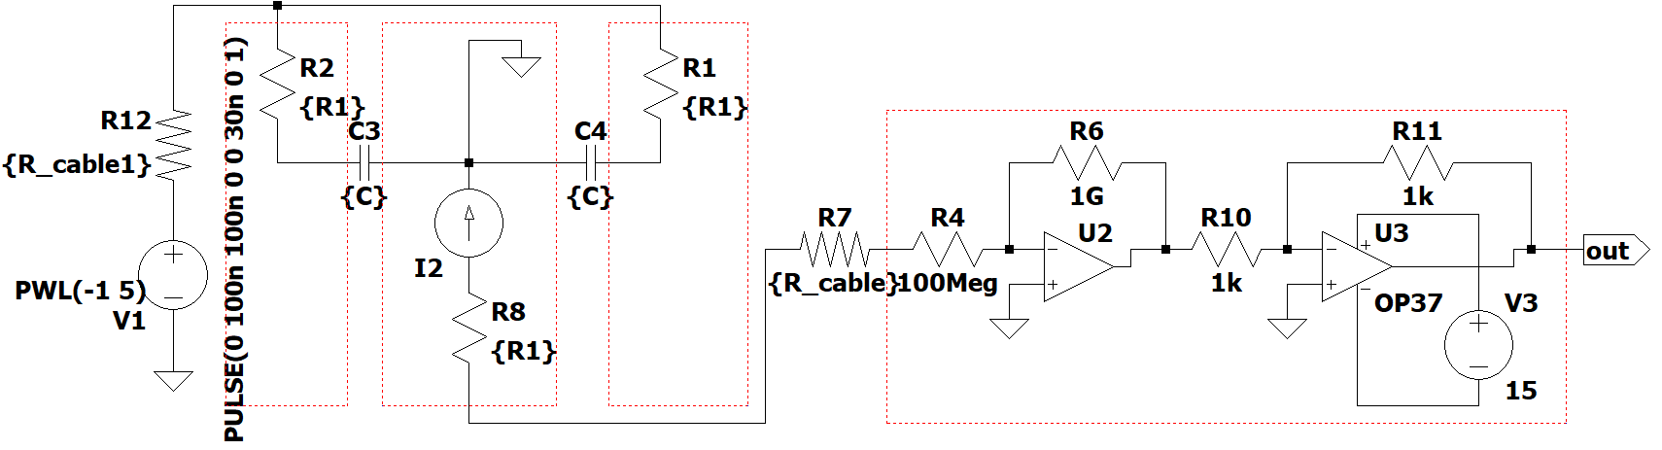
a)

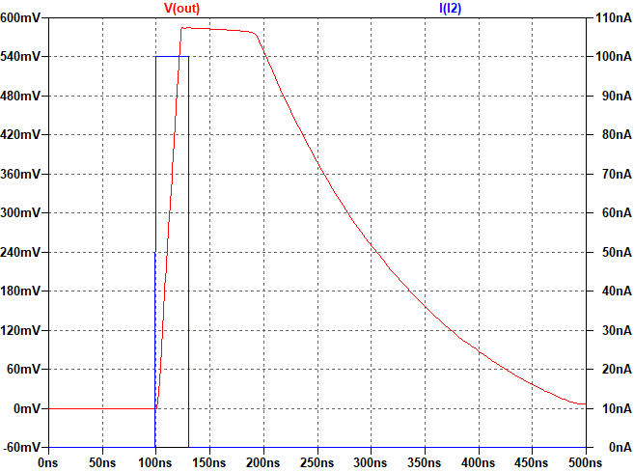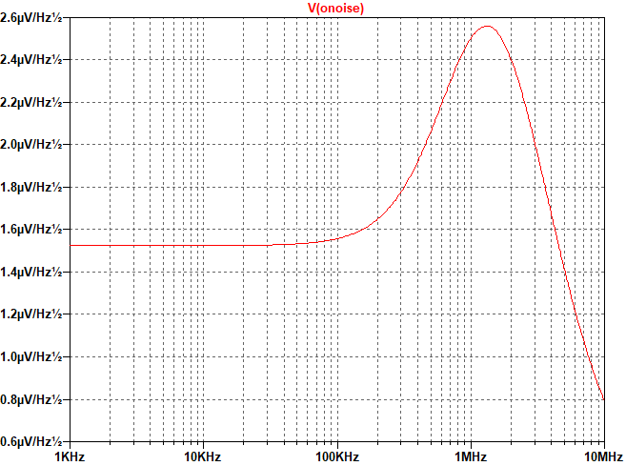
b) c)
Figure 2 – a) electronic analogue of RMS-CBM: metal-foil sensor (left) and charge integrator (right); b) simulation of the registered charge – input pulse (blue) and signal at the output of the charge integrator (red); c) Simulation of the noise spectral density at the output of the integrator.

Future simulation work will focus on refining the electronic model by implementing a complete and realistic charge integrator circuit, including frequency-to-digital conversion stages and detailed models of cables and connectors. These refined simulations will allow a more precise determination of the dynamic range, linearity, and long-term stability of the system.

- K. Agarwal, The compressed baryonic matter (CBM) experiment at FAIR – physics, status and prospects, Physica Scriptadoi:10.1088/1402-4896/acbca7.
- S. Ejiri, S. Itagaki, R. Iwami, K. Kanaya, M. Kitazawa, A. Kiyohara, M. Shirogane, and T. Umeda, “End point of the first-order phase transition of QCD in the heavy quark region by reweighting from quenched QCD,” vol. 101, mar 2020.
- S.B. Chernyshenko et al. RMS-R3 – the system for monitoring the region of interactions and background at the LHCb experiment (CERN). Nucl. Phys. At. Energy 24(2) (2023) 148.
- H. Malygina, V. Friese and M. Zyzak, "Hit reconstruction in the CBM silicon tracking system," 2016 IEEE Nuclear Science Symposium, Medical Imaging Conference and Room-Temperature Semiconductor Detector Workshop (NSS/MIC/RTSD), Strasbourg, France, 2016, pp. 1-6, doi: 10.1109/NSSMIC.2016.8069817.

